**Solving problems using array functions on rest countries data.**

1. **Get all the countries from Asia continent using Filter function**

var request = new XMLHttpRequest();

request.open("GET" , "https://restcountries.eu/rest/v2/all",true);

request.send();

request.onload = function(){

var data = JSON.parse(this.response);

var asianCountries = data.filter(item => item.region == "Asia").map(elem => elem.name);

console.log(asianCountries);

}

Console:-

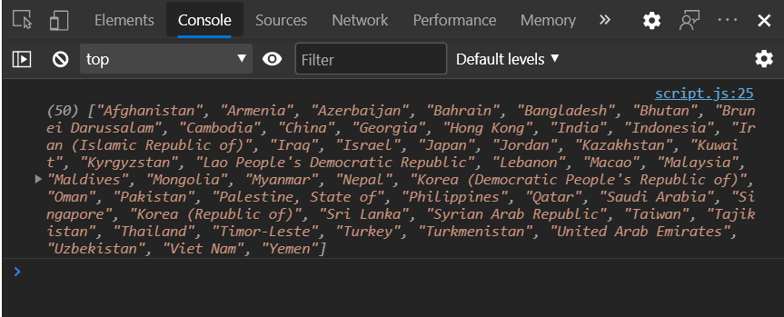

**2 . Get all the countries with population of less than 2 lacs using Filter function**

**var request = new XMLHttpRequest();**

**request.open("GET" , "https://restcountries.eu/rest/v2/all",true);**

**request.send();**

**request.onload = function(){**

**var data = JSON.parse(this.response);**

**var lessPopCountries = data.filter(item => item.population < 200000 ).map(elem => elem.name);**

**console.log(lessPopCountries);**

**}**

Console:-

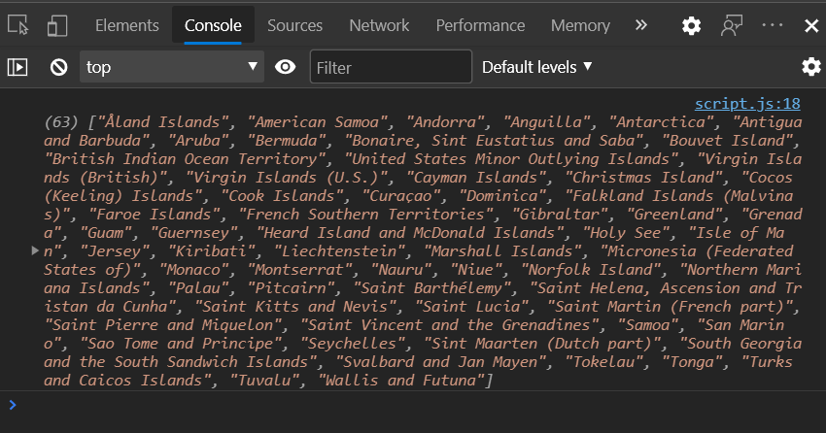

**3. Print the following details name, capital, flag using forEach function**

var request = new XMLHttpRequest();

request.open("GET" , "https://restcountries.eu/rest/v2/all",true);

request.send();

request.onload = function(){

var data = JSON.parse(this.response);

data.forEach(item => console.log("name : "+ item.name, "capital : " + item.capital, "flag : " + item.flag));

}

Console:-

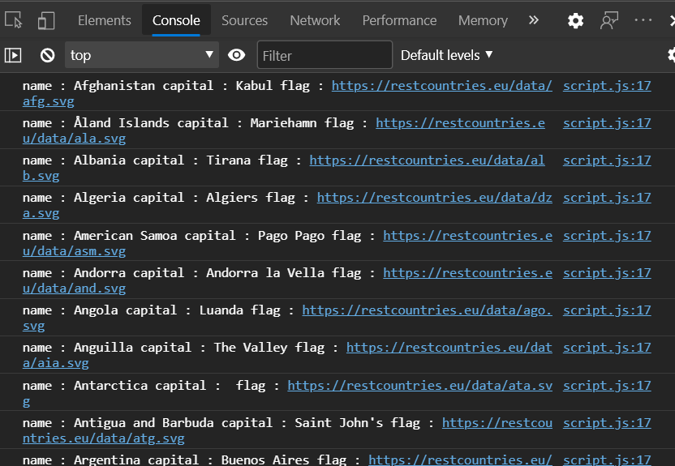

**4. Print the total population of countries using reduce function**

**var request = new XMLHttpRequest();**

**request.open("GET" , "https://restcountries.eu/rest/v2/all",true);**

**request.send();**

**request.onload = function(){**

**var data = JSON.parse(this.response);**

**var totalPopulation = data.reduce((acc,item) => acc+=item.population,0);**

**console.log(totalPopulation);**

**}**

**Console:-**

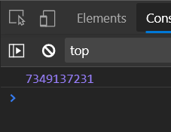

**5. Print the total population of countries in Asia continent using reduce and filter function**

**var request = new XMLHttpRequest();**

**request.open("GET" , "https://restcountries.eu/rest/v2/all",true);**

**request.send();**

**request.onload = function(){**

**var data = JSON.parse(this.response);**

**let totalPopulation = data.filter(item => item.region == "Asia").reduce((total,item)=>total+= item.population,0);**

**console.log(totalPopulation);**

**}**

**Console :-**

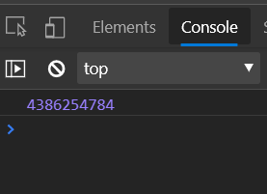

**6. Print the country which uses US Dollars as currency.**

**var request = new XMLHttpRequest();**

**request.open("GET" , "https://restcountries.eu/rest/v2/all",true);**

**request.send();**

**request.onload = function(){**

**var data = JSON.parse(this.response);**

**var usdCountries = data.filter(item => item.currencies[0].code == "USD").forEach(elem => {**

**console.log("name : " , elem.name , ", currency : " , elem.currencies[0].name )});**

**console.log(usdCountries);}**

**Console :-**

